Group 5: Noah Blake Smith, Miglé Petrauskaité, Benjamin Tu

**The Impact of Charter Schools on Academic Performance in Washington, DC**

**1 Introduction**

**1.1 Problem Statement**

For decades, students attending public schools in the United States have underperformed compared to those in peer nations (Dougherty 2009). In recent years, many American school districts have experimented with charter schools to combat this trend (Betts and Tang 2014). In 1996, the District of Columbia (DC) introduced charters to its school system, which will serve as the locus of our study (District of Columbia School Reform Act 1996). At the same time, policymakers are increasingly focused on the impact of early childhood education. This development comes from a growing body of literature showing early policy interventions are generally more effective than those later in life (Center on the Developing Child 2007; Yoshikawa et al. 2013). In this study, we will analyze the impact of attending charter schools on academic performance for children aged 3–11 in the DC area. Given DC charters use admission lotteries, we deploy a two-stage least-squares instrumental-variable (2SLS IV) model with inverse treatment likelihood weightings, where charter admission functions as an instrument for charter attendance. We will measure academic performance amongst students who enter the admissions lottery for PK3 charters using annual standardized tests in reading, mathematics, and science.

**1.2 Problem Context**

Since their inception in the 1990s, charter schools have evolved from a modest experiment to a ubiquitous element of the public education landscape (Wohlstetter et al. 1995). The rise of school choice affects not only students and their families but also teachers, who increasingly have multiple employment options within commuting distance. Particularly in urban and suburban settings, the expansion of charter schools has given teachers a range of employers from which to select, each serving a distinct demographic of students and operating under a different model. It is crucial to consider how access to high-quality instruction will change as the charter sector grows and as teachers and students change their sorting patterns across schools. These considerations should inform the broader debate on whether charter schools increase or decrease the quality of public education.

**1.3 Literature Review**

The literature evaluating the impact of charter attendance on academic performance is extensive. In meta-analyses, Cohodes and Parham (2021) and Gleason et al. (2010) found little difference in student academic achievement between charter and public middle schools overall, but they found substantial heterogeneous treatment effects across subpopulations—namely, charters boosted math scores for low-income students. Zimmer et al. (2009) also agreed that, on average, both schooling models have no significant influence on improving student test scores. However, although both charter and public school students obtained similar test scores, operational features such as smaller class sizes and more teacher autonomy make charter schools more likely to have a positive impact on any individual student’s achievement. On the contrary, Betts and Tang (2014) found that overall, both elementary and middle charter school students are performing better in math compared to their counterparts in traditional public schools. While no significant difference is observed in either elementary or high schools, students in middle charter schools achieved relatively higher reading scores. Similarly, Cheng et al. (2017) estimated that charter school students tend to improve their math and reading scores by 0.25 and 0.16 standard deviations, respectively, compared to public schools. Herein we provide an overview of the literature centered on charters *in the District of Columbia* specifically.

Schneider and Buckley (2003) surveyed 743 DC parents (402 charter, 341 public), asking them to rate aspects of their children’s schools through telephone surveys. They found, on average, charter parents rated their schools 17% higher than did their public counterparts. Their findings were robust to controlling for self-selection into charters using propensity score matching. Moreover, the researchers had similar findings examining a subsample of 450 parents, 402 charter and 48 whose children attended public after losing the charter lottery. A subsequent analysis by Buckley and Schneider (2006) using an expanded data set produced similar results.

Jacobs (2013) studied the relationship of the revealed preferences of DC charter parents to racial, economic, and linguistic segregation by using four regression models to test how parental choice is influenced by academic quality, student economic composition, student linguistic background, and charter school proximity. The author proffered a theory of choice whereby the preference for school proximity and linguistic homogeneity contributes to socioeconomic segregation, whereas academic similarity and quality become less important for parents when choosing certain charter schools. He tested the theory on a data set of 74 charter schools and found strong correlations between the level of racial segregation and the percentage of student enrollment from neighboring communities. In particular, if more students living in nearby places are enrolled, racial segregation will be exacerbated.

Curto and Fryer (2014) examined the impact of attending SEED schools on a sample of 129 DC students in grades 6–12. SEED schools are urban boarding schools that combine a “no excuses” charter model with a 5-day boarding program. Instrumenting admission by random lottery, the authors found SEED attendance increased reading scores by 0.211 standard deviations and math scores by 0.229.

Ferreyra and Kosenok (2018) developed a Bayesian equilibrium model of entry into the charter system. In their model, parents choose amongst public, private, and charters, and a regulator permits charter entry and requires charter exit. The authors estimated their model for a data set of 63 DC school campuses. They found charters generated net social gains, especially for non-white, low-income middle schoolers. The authors argue these results are, in part, explained by the strong regulatory oversight of the DC Charter Board, which sets high academic standards and shuts down failing charters.

**1.4 Stakeholders**

Our study subjects will include the cohorts of children who apply to DC charters for 3-year-old pre-K (PK3) in 2023–2030. We will track these cohorts through the end of grade 5 using child-level administrative and identified survey data. Our subjects’ parents and guardians will be important stakeholders. Ethics rules may require us to obtain consent from these individuals. If so, we would follow the standard procedures specified by the CITI Program in Human Research. Lastly, our implementation partners will be the administrators, teachers, and staff of DC public and charter schools. We will require an agreement with the DC school system that grants our research team access to individual-level student records of test scores and other such data. If school administration refuses to provide relevant data, one way to incentivize cooperation from DC school administrators is to offer free consulting services. Our expert researchers could work with administrators to improve school operations by drawing on the findings of the study.

**1.5 Motivations**

The primary motivation of this study is to investigate the quality of different types of schools as an engine for improving student performance. To that end, we aim to evaluate whether DC charter schools improve student performance relative to traditional public schools. According to the most recent data available, only 34% of DC students in grades 3–6 were proficient in mathematics by Common Core Standards (Office of the State Superintendent of Education 2019). Similarly, just 38% were proficient in reading/writing. While mean DC charter scores were generally above their public counterparts, it is improper to attribute these differences to education quality without further analysis, as student populations may systematically differ. Our study will take advantage of a natural experiment: Seats at DC charters are allocated by random lottery. We will limit our analysis strictly to lottery entrants, which prevents systematic differences between public and charter students in our sample. By instrumenting charter admission by random lottery, we will obtain an unbiased estimate of the impact of charter attendance on test scores. Moreover, as far as we are aware, to date, there has been no comprehensive longitudinal study evaluating the impact of DC charters on academic performance. Curto and Fryer (2014) came closest in their study of a small cohort (*N* = 129) that entered the lottery for SEED schools, which serve grades 6–12. Our proposal is distinguished from Curto and Fryer (2014) by its younger subjects and a broader scope of traditional charter schools. Lastly, our research will be the first to study the impact of attending DC charters since the outbreak of the COVID-19 pandemic. The pandemic permanently changed the structure and operations of educational institutions in DC and across the globe, which raises questions about the applicability of previous studies to today’s policymakers. Our research will add to the growing body of literature on schooling in a post-pandemic world.

**2 Context**

**2.1 Market Failure**

Conceptualizing the traditional US education system as a market, consumers (i.e., families) have two methods to express dissatisfaction: voice and exit.[1] Voice is the primary option used by consumers of traditional public schools. Examples include school-board elections and parent-teacher association (PTA) meetings. However, the option to exit public schools has traditionally been unavailable to families unable to afford private schooling. Without the exit option, the traditional public school system is monopolistic by nature. Indeed, the entrenched monopolistic power of the education establishment, which may be exacerbated by teachers’ unions and high-level administrators, contributes to the bureaucratization of public schools, making progress difficult. Thus, many students have been “trapped” in failing schools by the traditional system.

Opening the education system to competition may be an effective way to overcome bureaucratic opposition in public schools. Moreover, school choice would allow families to exit failing schools, as well as select the institutions that best serve their children’s needs. Public schools, faced with the threat of exit, would be forced to operate more effectively or lose students. These market forces should lead to increased educational innovation and “best practice” models, as well as more efficient allocations of existing resources. Thus, school choice would principally benefit students poorly served by current public schools, especially those “trapped” in large, failing urban districts. Charter schools aim to give families that option. In doing so, districts that provide charter options seek to use a market mechanism that pushes schools to improve by adapting to consumer preferences.

Opponents argue charters worsen education at public schools by “cream skimming” (targeting only high-performing students). Thus, the presence of charter schools may affect school composition more broadly by simply attracting better students. If there is evidence of student sorting happening, we would expect to see the proportion of high-performing students in public schools go down compared to charter schools. If that is true in DC, it would imply that charters are better at attracting talented students, rather than providing better education. However, existing literature on DC charters is inconsistent with the cream-skimming hypothesis. For example, Lacireno-Paquet et al. (2002) found DC charter and public schools have similar socioeconomic compositions, although they are somewhat less likely to serve the poorest populations. This finding is consistent with what we call the “strainer hypothesis,” whereby charters may “strain out” high-need students. However, an alternative explanation is that low-income parents may be less likely to apply for charters, perhaps due to having less information or time availability.

Would giving parents an exit option force public schools to close as they underperform and lose students, as critics contend? One crucial aspect of market discipline is the possibility of exit from the marketplace. Firms in a competitive market are subject to forces that will require them to exit if they cannot satisfy their customers. These same forces do not apply to public schools—the government, as a supplier of education, is largely insulated. The government essentially guarantees a set of neighborhood buyers for a given local public school by treating education as a public good, funding it through taxes, and eliminating consumer pricing signals for its consumption. As a result, there is significantly less pressure on underperforming public schools to improve. Still, losing students to charter schools means receiving less funding as the money follows each student, which, we believe, may induce public schools to increase their attractiveness to consumers.

**2.1 Theory of Change**

**2.2.1 Autonomy**

The primary outcome of interest in this study is academic achievement, measured by standardized exam scores (as detailed in Section 3). We hypothesize that certain structural features of charter schools are conducive to improved student performance. Namely, charters are characterized by a degree of autonomy, innovation, and accountability that lead to certain operational improvements. These characteristics influence key factors that affect academic performance, such as class sizes, teacher quality, the effectiveness of pedagogy, and parent/guardian involvement. In the following paragraphs, we deconstruct the mechanisms by which charter schools lead to improved student achievement, laying the theoretical groundwork for our research design.

To start, charters have greater autonomy than do public schools because they are independently operated (but publicly funded). Whereas traditional public schools have top-down rules governing their operations, charters are largely free from such constraints. Indeed, they are granted more flexibility than district-operated public schools due to regulatory waivers and exemptions (Wohlstetter et al. 1995). As a result, charters have a large degree of control over their spending allocations, personnel decisions, curricula, and pedagogy (Wohlstetter et al. 1995). This greater autonomy, we theorize, facilitates the processes by which administrators implement changes and improvements, such as reducing class sizes (Wohlstetter and Griffin 1998). For instance, Lacireno-Paquet et al. (2002) found that charters enrolled, on average, half the students their public counterparts did, which allowed for smaller class sizes that enhanced learning. We, therefore, anticipate smaller class sizes at DC charters to similarly improve performance relative to public schools.

Moreover, a higher degree of autonomy may also translate to an easier process of hiring high-quality teachers and letting go of underperforming ones. Charters can more easily fire poor performers and offer benefits that attract talented, committed educators. Accordingly, we should see a gap in metrics of teacher quality, such as instructor absenteeism.[2] Indeed, Griffith (2017) found teachers at DC public schools were at least four times as likely to be chronically absent as their charter-school peers. The author concluded this gap was, in part, attributable to the generous leave policies enshrined in state laws and local collective bargaining arrangements. Moreover, multiple studies have demonstrated that 10 days of teacher absences cause more than 10 days of learning loss among students (see Herman and Rockoff 2012; Miller et al. 2008; Clotfelter et al. 2007). Hence, we theorize that charters should lead to better student performance.

Finally, charters’ autonomy may provide teachers and administrators greater latitude to test and tweak classroom curricula and pedagogy. Such flexibility is likely to improve education delivery and thus student performance. We might test this hypothesis in practice using student/parent surveys and feedback evaluations (Berk 2005).

**2.2.2 Innovation**

The market forces acting on charters generate incentives for innovation that traditional public schools lack. For example, the charter-school literature demonstrates the prevalence of educational management organizations, also called educational service providers. These firms offer a wide range of services that help streamline the administrative performance of charters. We theorize that the presence of such management organizations lubricates daily administrative operations, facilitating the effective allocation of resources and saving time that can be put toward improving education quality.

This compels us to consider whether the pedagogy at charter schools, which we expect is influenced significantly by the organizational and management innovations described above, may play a role in affecting student performance via instruction and curriculum. Early literature on charter schools leads us to believe that this may indeed be the case. For example, a study of charters in California found they used a combination of traditional classroom-based instruction and novel approaches (e.g., independent study), which increased student achievement (Powell et al. 1997). Moreover, a Michigan study concluded that charters, on average, innovated and updated their curricula more frequently than traditional public schools (Mintrom 2000). The author of the study also noted that some of the most innovative practices in Michigan were observed in charter schools.

In contrast, public schools have few incentives to innovate and have been observed to increase in bureaucracy over time in a process called “hypertrophy” (Posner 1986). They also lack strong incentives to produce high academic results among their students because, unlike charter schools, financing persists regardless of results. This situation, in effect, makes a captive audience of families lacking the means to pay private tuition or relocate. As such, we theorize that by allowing for a wide range of curricular and pedagogical approaches—as measured by, e.g., textbooks used, types of audio-visual materials used, and lesson styles (lecture, discussion, etc.)—charter schools are more likely to facilitate higher student achievement than public schools.

**2.2.3 Accountability**

Finally, accountability, especially for student performance, is frequently used as the key argument in favor of charter schools (Nathan 1996; Finn et al. 2000). As mentioned above, charter schools are released from many state and district regulations that govern traditional public schools. In exchange for this flexibility, they are required to be accountable for the quality of student results and risk being shut down, should they fail (Wolderie 1990). We believe that, because they must compete with public schools, charters are pressured to recruit higher-quality teachers, leading to better student outcomes.

Charters may also focus more on *internal* accountability—that is, accountability to teachers, parents, and students rather than to their chartering agencies—in order to retain highly qualified staff and steady student enrolment rates (Wohlstetter and Griffin 1997). As one study observed, “the fact that charter schools must maintain relationships of trust and confidence with parents and teachers, as well as with government, motivates the intense internal collaboration that leads to internal accountability” (Hill et al. 2001). In short, unlike traditional public schools, a charter may be closed if it fails to attract and retain students or if it fails to perform up to the government’s standards. As such, charters have a double incentive to perform well: Their students’ progress is monitored both by external actors (the government) and internal actors (teachers and parents).

Apart from internal accountability, charter schools are also socially accountable for addressing the limited educational opportunities and having a student body that represents the local community in terms of economic condition and race. As the demand for charter schools continuously outweighs its supply in DC, lawmakers introduced the My School DC application in 2014 to promote a better distribution of educational resources. In particular, the lottery system is intended to help alleviate excess demand by efficiently allocating seats in charter schools (Blagg, Rosenboom, and Chingos 2018). Although the lottery system provides a relatively equal opportunity for students to apply to charter schools, it leaves out disadvantaged students who are not getting additional assistance and are more likely to attend public schools otherwise. Therefore, the DC Council passed the Expanding Equitable Access to Great Schools Act of 2020, which aims to increase charter access for at-risk students, such as the unhoused and those with educational gaps (DC Public Charter School Board 2021). The act implies that charter schools are also required to mitigate the lack of educational resources for deprived students. Meanwhile, enrolling more at-risk students also helps advance overall student performance in charter schools. In other words, students tend to have a greater academic performance in a more economically and racially diverse school environment (Min and Goff 2016). Therefore, it has become more important for charter schools to take responsibility to have a more diverse student population to maximize their overall student academic performance and help disadvantaged students who otherwise are becoming less likely to submit an application with the rising demand and long waitlists of the lottery system.

To summarize, in this study we hypothesize that attending charter schools leads to improved student performance and well-being compared to attending public schools in DC. We ground our reasons for this in the literature on the topic, which highlights how the combination ofautonomy, innovation, and accountabilitymay positively affect academic outcomes among charter school students. We believe the main ways in which the described mechanism might affect our outcome of interest—student performance—is through smaller class sizes, teacher absenteeism, higher teacher quality, and better pedagogy.

**3 Design and Treatment**

We will estimate how DC charter schools impact academic achievement in the 8 cohorts of students entering PK3 from 2023 through 2030, each of which we will track through grade 5. We will use the PK3 lottery as a randomization mechanism in a two-stage least-squares instrumental-variable (2SLS IV) model. We will control for variation in the probability of treatment across lottery entrants using simulated weights (see Section 3.2.3 for details). Measurements of student outcomes will be drawn from standardized exams.

**3.1 My School DC Lottery**

In the DC school system, families may enter their children of any age into the annual My School DC Lottery for the opportunity to attend charter schools. Families rank up to 12 charters for their children to attend. An optimization algorithm matches students with schools on their lists. When demand for a charter exceeds supply, seats are allocated by random lottery. Lottery winners have the choice to accept their admission or attend their local public schools. Lottery losers only have the opportunity to attend their local public schools.[3] We illustrate the application process with the flowchart below. Our study sample comprises *only* those students who pass through the green “yes” in the flowchart, i.e., are subjected to the randomization process.

**Figure 1: My School DC Lottery Process**

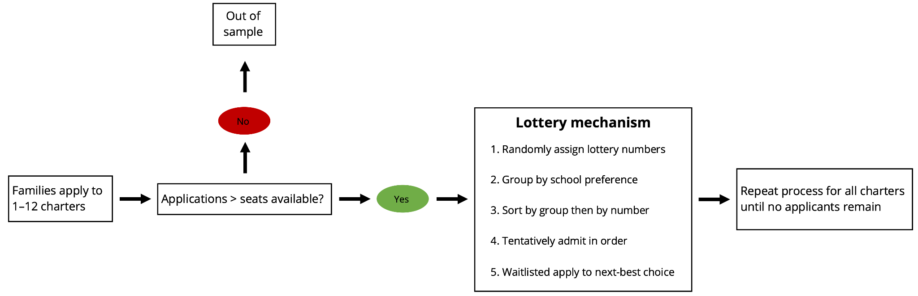

The My School DC Lottery employs a modified Gale-Shapley algorithm, also referred to as a “deferred-acceptance (DA) algorithm,” for optimizing student-school matches (Common Lottery Board 2022). To illustrate the algorithm at work, consider a single charter school following the lottery mechanism in the flowchart above. First, the algorithm assigns random numbers to all students who ranked that charter. Second, the algorithm groups families by priority groups, also called preference groups, which are determined by the school. For example, the school may give priority to students who live close to the school or those with siblings who already attend. Third, the algorithm ranks the families in each priority group by their randomly assigned lottery numbers. That is, students in the first priority group are arranged in the order of their lottery numbers, then students in the second priority group, and so on. Fourth, the algorithm *tentatively* admits families in the first priority group in order of their lottery numbers. The algorithm repeats this process for the second priority group, then the third, and so on, until all spots are filled. Fifth, the remaining unadmitted applicants are tentatively waitlisted, and then they apply to their next-best school. At each charter school, this 5-step process is repeated for all applicants, including new applicants, tentative rejects of other schools, and tentative admits of other schools. The algorithm ends when there are no new applications.

According to Abdulkadiroğlu et al. (2017), this algorithm has two main advantages. First, “any student who prefers another school to the one he has been assigned must be outranked at that school, either because everyone assigned there has higher priority, or because those who share the student’s priority at that school have higher lottery numbers.” Second, the algorithm is “strategy-proof, meaning that families do as well as possible by submitting a truthful preference list (for example, there is nothing to be gained by ranking under-subscribed schools highly just because they are likely to yield seats).”

The DC school system serves approximately 100,000 students *across all grades*, about half of whom attend charters (Common Lottery Board 2022). DC has approximately 130 charter campuses and a similar number of public campuses. In any given year, about 20,000 (20%) DC students across all grades apply for charters. Of those, approximately 5,000 apply for the PK3 lottery.

In the 2022 My School DC Lottery, the most recent data available, 4,761 families applied to PK3, vying for 6,662 PK3 seats at 86 school campuses (Common Lottery Board 2022). On average, they selected 5 charters. However, some charters were oversubscribed, while others were undersubscribed, so not all families could receive their first choices, nor were all charter seats filled. The algorithm matched 2,742 (57%) families with their first-choice charters, 1,537 (33%) with *only* non-first-choice charters, and 482 (10%) with no charters at all. Unfortunately, DC does not publish the number of admits who ultimately enroll at and attend charters. However, previous studies of confidential data pooled over the 2014–2018 admissions cycles showed 80% of students admitted to PK3 ultimately take up their seats (Greenberg et al. 2020; Monarrez et al. 2020). This figure is similar to those found in previous studies of charter schools in peer US cities (Angrist et al. 2010; Abdulkadiroğlu et al. 2011). In Section 3.2, we discuss the issues regarding causal identification that arise from this “choice element” and how we adjust for variation in the probability of treatment across applicants.

It appears that the distribution of applicants by ward closely resembles the distribution of public school enrollment by ward. DC has 8 wards with varying demographic compositions. While PK3-specific data are unavailable, the distribution of all charter applicants by ward was within 3% of the overall school enrollment in 2022. For example, applicants residing in Ward 4 comprised 18% of the applicant pool, and Ward 4 public/charter students comprised 17% of all students in the DC school system (Common Lottery Board 2022). Unfortunately, there are no publicly available data regarding the *locations* of the charters to which families residing in Ward 4 applied. While families in any ward may apply to charters in any ward, previous studies of revealed charter preferences have suggested proximity plays a role in parental charter selection (Jacobs 2011).

By contrast, the match rate is uneven across wards in DC. The match rate is defined as the percentage of applicants matched with at least one charter on their list. PK3-specific data are unavailable, but the overall match rates by ward are. In 2022, the match rates ranged from 64% in Wards 1 and 2 to 85% in Ward 7 and 88% in Ward 8 (Common Lottery Board 2022). These disparities are due to differences in parental preferences, proximate school supply, and the age distribution of applicants, inter alia, across wards. As such, the probability of being treated (i.e., not attending charter due to unfavorable lottery outcomes) may differ by ward.

**3.2 Model Design**

**3.2.1 Basic Model**

We build on the methodological approach of Angrist, Imbens, and Rubin (1996) to estimate the impact of charter attendance on test scores, which has become standard in the econometric literature evaluating charters (Hoxby and Murarka 2009; Angrist et al. 2010; Abdulkadiroğlu et al. 2011; Dobbie and Fryer 2011; Curto and Fryer 2014; Walters 2018; Setren 2019). The authors use a two-stage least-squares instrumental-variable (2SLS IV) model. The first stage is a regression of a charter attendance dummy variable on a treatment (admitted) dummy variable. The second stage is a regression of the outcome variable, namely test scores, on the predicted attendance variable. We will cluster our standard errors by school due to possible non-independence in outcomes.



**Table 1: Abbreviated Summary of Variables**

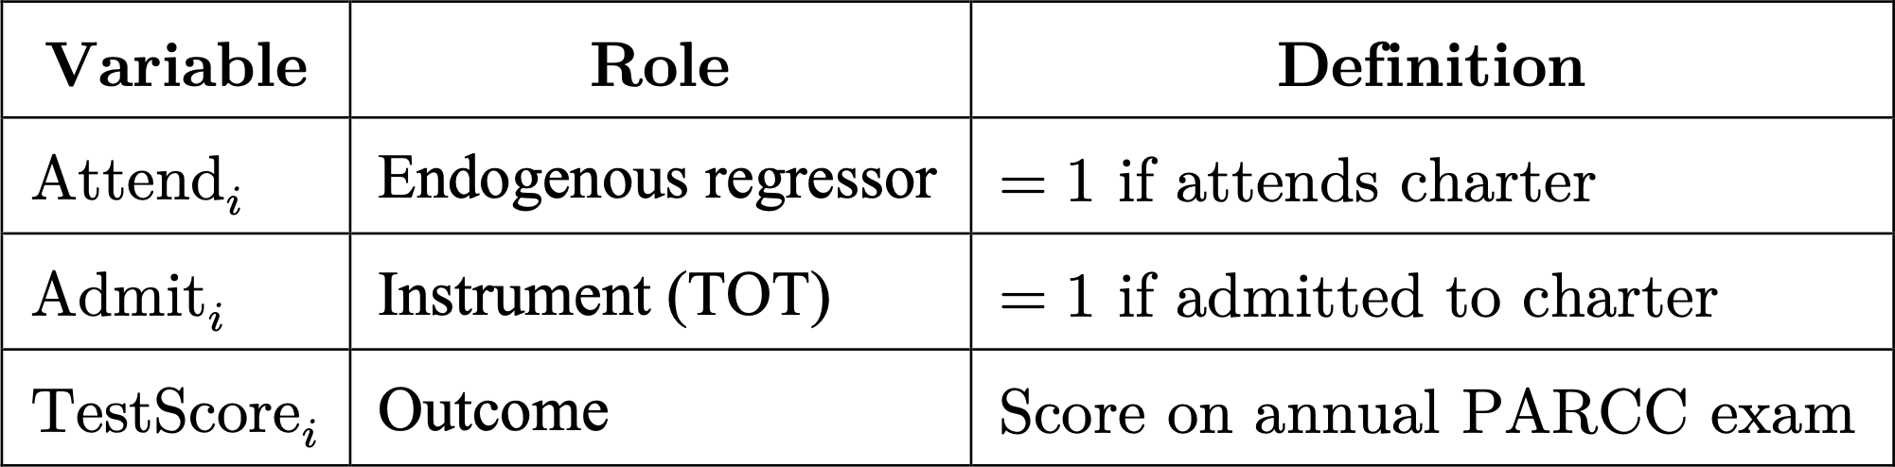

In our study, we will estimate the treatment-on-the-treated (TOT) effect by comparing the academic performance of lottery entrants who ultimately attend a charter school versus those who ultimately attend a public school. The TOT effect represents the average impact of *attending* a charter on academic performance relative to attending a traditional public school, amongst lottery entrants.[4] We will examine the TOT effect pooled over the study period as well as by year, which we expect to compound over time.

We will track students from PK3 through grade 5, the last year of elementary school. By stopping at grade 5, we focus our analysis on elementary schools. Moreover, the design opens the possibility of examining TOT effect heterogeneity across charters and grade levels.

**3.2.2 Model Implementation**

We will use charter admission in the PK3 lottery as an instrument for attendance to estimate the TOT effect. We expect a strong correlation between charter admission and subsequent attendance, given the 80% takeup rate in 2014–2018 (Greenberg et al. 2020; Monarrez et al. 2020). Thus, admission meets the relevance condition of the 2SLS IV model.

We also believe the exclusion restriction is met if admission is *truly* random, as it would only affect outcomes through charter attendance. However, in *practice*, admission is not *truly* random at the *system-wide level* (only at the school-specific level), since parents’ charter selections are not random and the DA matching algorithm incorporates school-determined priority groups in lottery admissions. For example, one possibility is that applicants to lower-quality charters have a higher probability of admission. If that is the case, the probability of admission would be correlated with unobserved school quality. Since charter proximity influences parental preferences (Jacobs 2011), another possibility is that applicants in wards with greater supply-demand imbalances for charter seats have higher/lower probabilities of admission. If true, that would violate the exclusion restriction. In Section 3.2.3, we describe a procedure for estimating inverse treatment probability weightings that account for such possibilities.

We have chosen the PK3 lottery in particular for two main reasons. First, policy interventions tend to be more impactful on the youngest children (Center on the Developing Child 2007), and PK3 is the youngest lottery cohort. Second, PK3 lotteries usually have the highest success rate in matching students with their top-choice charters. In 2022, we expect admission is strongest as an instrument for attendance in PK3, as compared to other grade levels. We already know the PK3 *compliance rate* (the share of admits who later enroll at charters) was 80% pooled over 2014–2018 (Greenberg et al. 2020; Monzarrez et al. 2020). Moreover, recent data show the *match rate* (the share of applicants matched with at least one charter on their list) was 90% for PK3, the highest of any grade (Common Lottery Board 2022). While the compliance rate for other grade levels is not publicly available, the pooled match rate was 73% (Common Lottery Board 2022). If we assume lower match rates make for lower compliance rates, it follows that PK3 should have the highest compliance rate of any grade and hence make the strongest IV.

**3.2.3 Likelihood of Treatment**

It is important to note that the probability of treatment varies across applicants. For example, applications to highly regarded charters are more likely to exceed capacity, requiring selection by random lottery. Therefore, applicants have different likelihoods of treatment according to their school selections. To account for these differences, we would implement inverse treatment likelihood weighting in our analysis using the methodology of Abdulkadiroğlu et al. (2017) as implemented by Monarrez et al. (2020) called the deferred-acceptance (DA) propensity score method.

In the My School DC Lottery, the probability of admission is determined by the applicant’s priority group and their ranked-choice list of schools. Abdulkadiroğlu et al. (2017) prove the likelihood of admission—the deferred-admission (DA) propensity score—is an effective method to account for differences across the treatment and control groups when drawing causal inferences.

Following Monarrez et al. (2020), we will use a simulation approach to calculate DA propensity scores in our study. In this approach, we compute the scores by repeatedly simulating the My School DC Lottery procedure, holding constant applicants’ priority groups, school rankings, and seat availability (Monarrez et al. 2020). Differences between trials are driven by randomness in the assignment of lottery numbers. After each iteration, the school to which each student was matched is stored in a dataset. After running a sufficiently large number of trials—Monarrez et al. 2020 recommend 25,000—we will have a dataset where each row is a student, each column is a charter, and each cell value is a student-charter-specific *match count*, the number of times the student matched with that charter across all trials. The DA propensity score for any applicant is defined as the probability of match occurrence, i.e., the sum of matches across all charters (for each applicant) divided by the number of trials completed. By implementing DA propensity scores in our 2SLS IV model, we can compare outcomes across treated and untreated individuals, controlling for differences in the probability of treatment.

It is imperative to underline the methodological rigor of the DA propensity score method as compared to traditional propensity score methods. According to Monarrez et al. (2020), “the DA propensity score is based on the random assignment to treatment (the ‘gold standard’ of causal inference) driven by the lottery, and the score ensures that we compare individuals with similar ‘risk’ of being treated. In contrast, common propensity score methods rely on the strong assumption that the treatment can be assumed to be as good as randomly assigned by accounting for observable differences between treatment and control,” whose validity is commonly in doubt.

**3.3 Testing Our Theory of Change**

We will evaluate our theory of change by testing the difference in means between public and private schools across a variety of relevant metrics. Suppose our IV shows attending a charter increases test scores. Then, we will examine, for example, class sizes across public and charters. If charters’ mean class size is smaller at a statistically significant level, that would be consistent with our theory of change. As another example, consider our theory of demand for charters. We can test this theory by examining the “test score elasticity of demand”—i.e., the change in demand for charters whose test scores significantly rise or fall—amongst the 8 cohorts we will study (students entering PK3 from 2023 through 2030). Under our theory, we would expect, for example, that applications to a charter rise after it shows significant improvement in performance (although the timeline may be delayed due to information frictions). As the last example, consider our theory of attendance. We hypothesize that higher attendance and lower tardiness will increase student academic performance. If charters have lower rates of absence and tardiness at a statistically significant level, that would tend to support our theory of change.

**3.4 Data Sources and Definitions**

We provide a summary of our data sources in the table below. In the subsequent sections, we include detailed explanations of each.

**Table 2: Summary of Data and Sources**

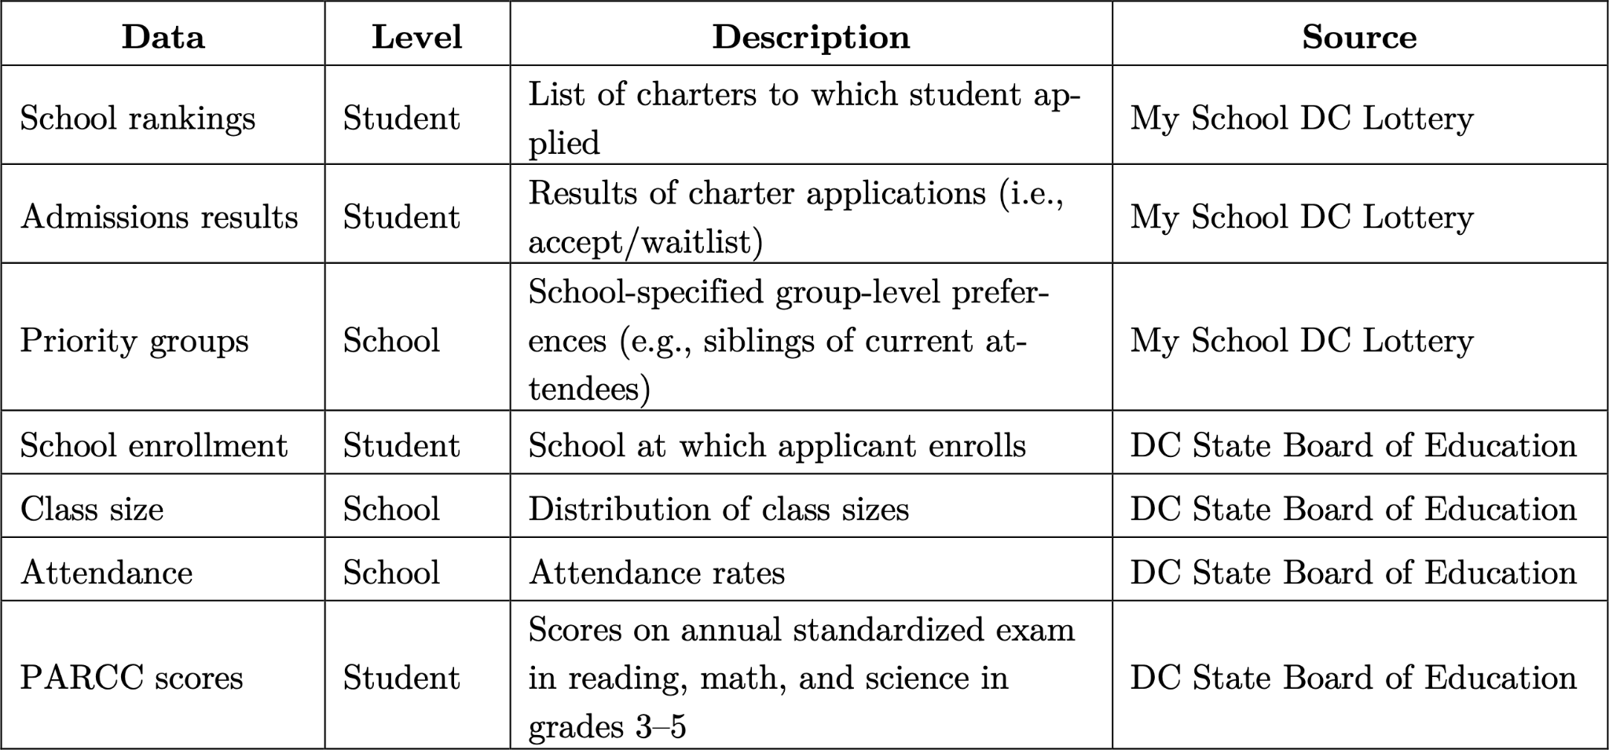

**3.4.1 Charter Lottery**

The lottery data will come from the My School DC Lottery, which is run by the DC school system. For each study subject, we will request proof of lottery entrance, school selection(s), lottery results, and school selected to attend. In addition, we will aggregate what priority groups each charter considers (sibling attendance, in-bound proximity, etc.) and how each ranks them. These data are publicly available.

**3.4.2 School Enrollment**

The DC school system maintains a centralized database of students and school enrollment. We will request the records corresponding to our study subjects. We may use such records to continue tracking subjects who switch schools within the DC system.

**3.4.3 Test Scores**

We have endeavored to use objective measures of academic performance unlikely to be contaminated by cross-school differences in operations.[5] To that end, we have chosen test scores in reading/writing, mathematics, and science as primary outcome measures. We will use test scores in aggregate as well as by subject to investigate possibly heterogeneous effects.

Our primary data will come from the Partnership for Assessment of Readiness for College and Careers (PARCC), an annual standardized exam in reading/writing, mathematics, and science. The DC school system already requires all students, public and charter, in grades 3–11 to take the math and reading/writing sections of the PARCC each year. Grades 5 and 8 are required to take the science sections. We will request from DC school administrators our subjects’ PARCC scores for grades 3, 4, and 5.

We believe the PARCC will serve as a reasonably accurate measure of student performance for a few reasons. First, it tests students’ ability to think critically and solve real-world problems, without overreliance on memorization. For example, the PARCC avoids jargon, such as “polynomial roots,” and instead favors more-plain language, like “when the equation equals zero” (DCPS 2022). We believe that such skills-based tests, in contrast to knowledge-based tests, are less prone to biased questions. Second, the PARCC assesses students’ progress toward the Common Core Standards, a federal initiative dating to 2010. While imperfect, these standards provide a well-defined, reasonable framework for educational achievement, which is widely used to benchmark academic performance. Third, we believe subjects will, by and large, put forth a genuine effort on the PARCC, as it factors into their report cards. Fourth, the PARCC would be less intrusive on school operations and less burdensome for school leadership to administer. These factors, we believe, would increase the likelihood of the DC school system approving our study.

**3.4.4 Measures of Our Theory of Change**

Additionally, we will request data from the DC school system necessary for testing our theory of change. To test the examples discussed in Section 3.3, we will request data on school class sizes, applications submitted by charter, and rates of absence and tardiness. The DC school system already makes such school-level data publicly available, so we can infer they already have a centralized reporting system for such information.

**3.5 Preliminary Results, Statistical Power, and Sample Size Calculations**

It is imperative that our study’s sample is sufficiently large to demonstrate the hypothesized impact of charter attendance on test scores. Accordingly, we estimated the minimum sample size (MSN) of our study using Stata simulation and power calculations.[6]

In our simulation, we generate 5,000 students who apply to the My School DC Lottery for PK3. Each child has an innate ability and a designated local public school. The child applies to exactly one charter, which he/she chooses at random from amongst all charters with equal probability. Each school, public and charter, is randomly assigned a quality score. To reflect distributional differences, we draw public quality scores from a normal distribution with a mean of 100 and a standard deviation of 15, while charter scores are drawn from a normal distribution with the same standard deviation but a mean of 105. The difference in the mean is based on our literature review which demonstrates that students on average perform better academically at charter schools Gleason et al. 2010). We define the child’s hypothetical test score attending a school as a Cobb-Douglas education production function of the child’s innate ability and school quality (Polachek, Kniesner, and Harwood 1978). We assume an admitted student chooses to attend the charter school if his/her test scores would be higher there than at the local public school. Children who lose the lottery and those whose test scores would be higher at their public schools choose to attend public schools. After these decisions are made, our simulation loops through all waitlists until no more applicants remain or all seats are filled. Our simulation makes a fair number of simplifications to the complexity of the real system. However, it nevertheless gives us a thumbnail of study feasibility.

We conducted a baseline calculation of the MSN, assuming a significance level of 5% and power of 0.8. The basis of our calculation was the coefficient of the second stage of our 2SLS IV model. (For space considerations, we do not discuss our calculations for the first stage, given recent studies already found a strong relationship [Monarrez et al. 2020].) After running 25,000 trials, we found a mean MSN of 148 students and a standard deviation of 16.8. This number is eminently feasible, given 4,800 PK3 applicants, on average, experience the random lottery mechanism each year (Monarrez et al. 2020).

Furthermore, we conducted a sensitivity analysis on our power calculations, which produced results consistent with our original findings. First, we varied the minimum detectable effect (MDE), holding the power constant at 0.8. Our results are summarized in Figure 2, which shows the mean sample size peaks around 225 at the 1% significance level. Furthermore, visual inspection shows the absolute maximum size found across any level, approximately 301, is far below the study population available. Second, we varied the power of our simulation, holding the significance level constant at 5%. Our results, depicted in Figure 3, are consistent with those of Figure 2. Indeed, these calculations show our study population should be more than sufficient to produce statistically significant and convincing results.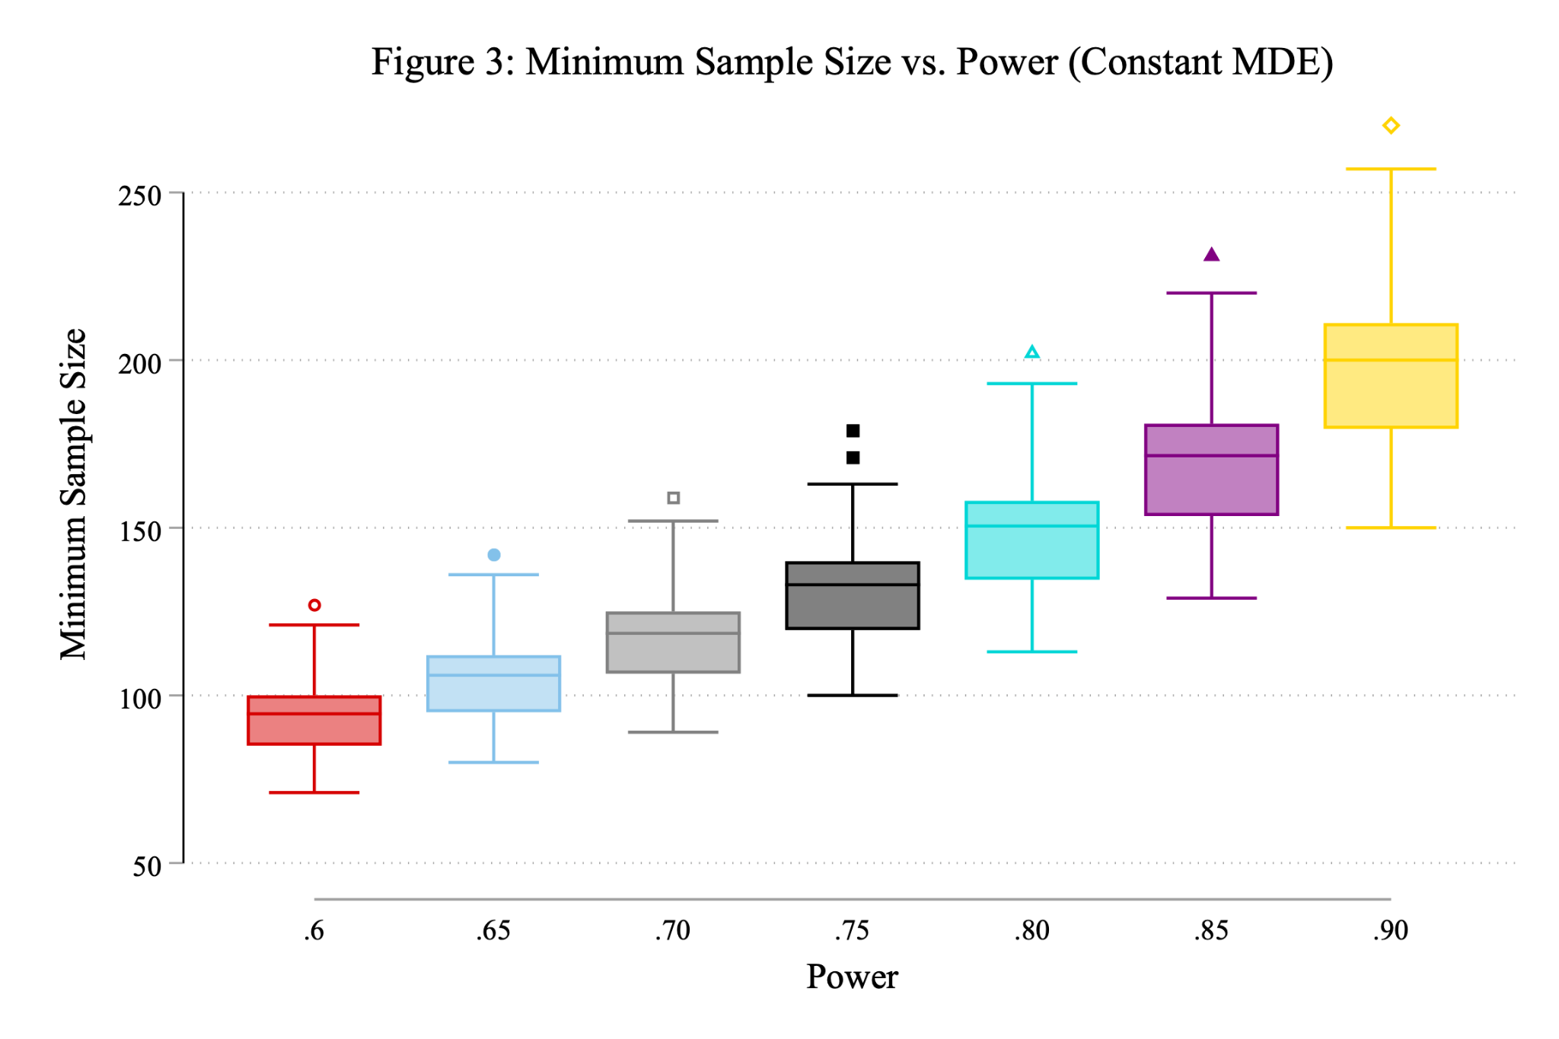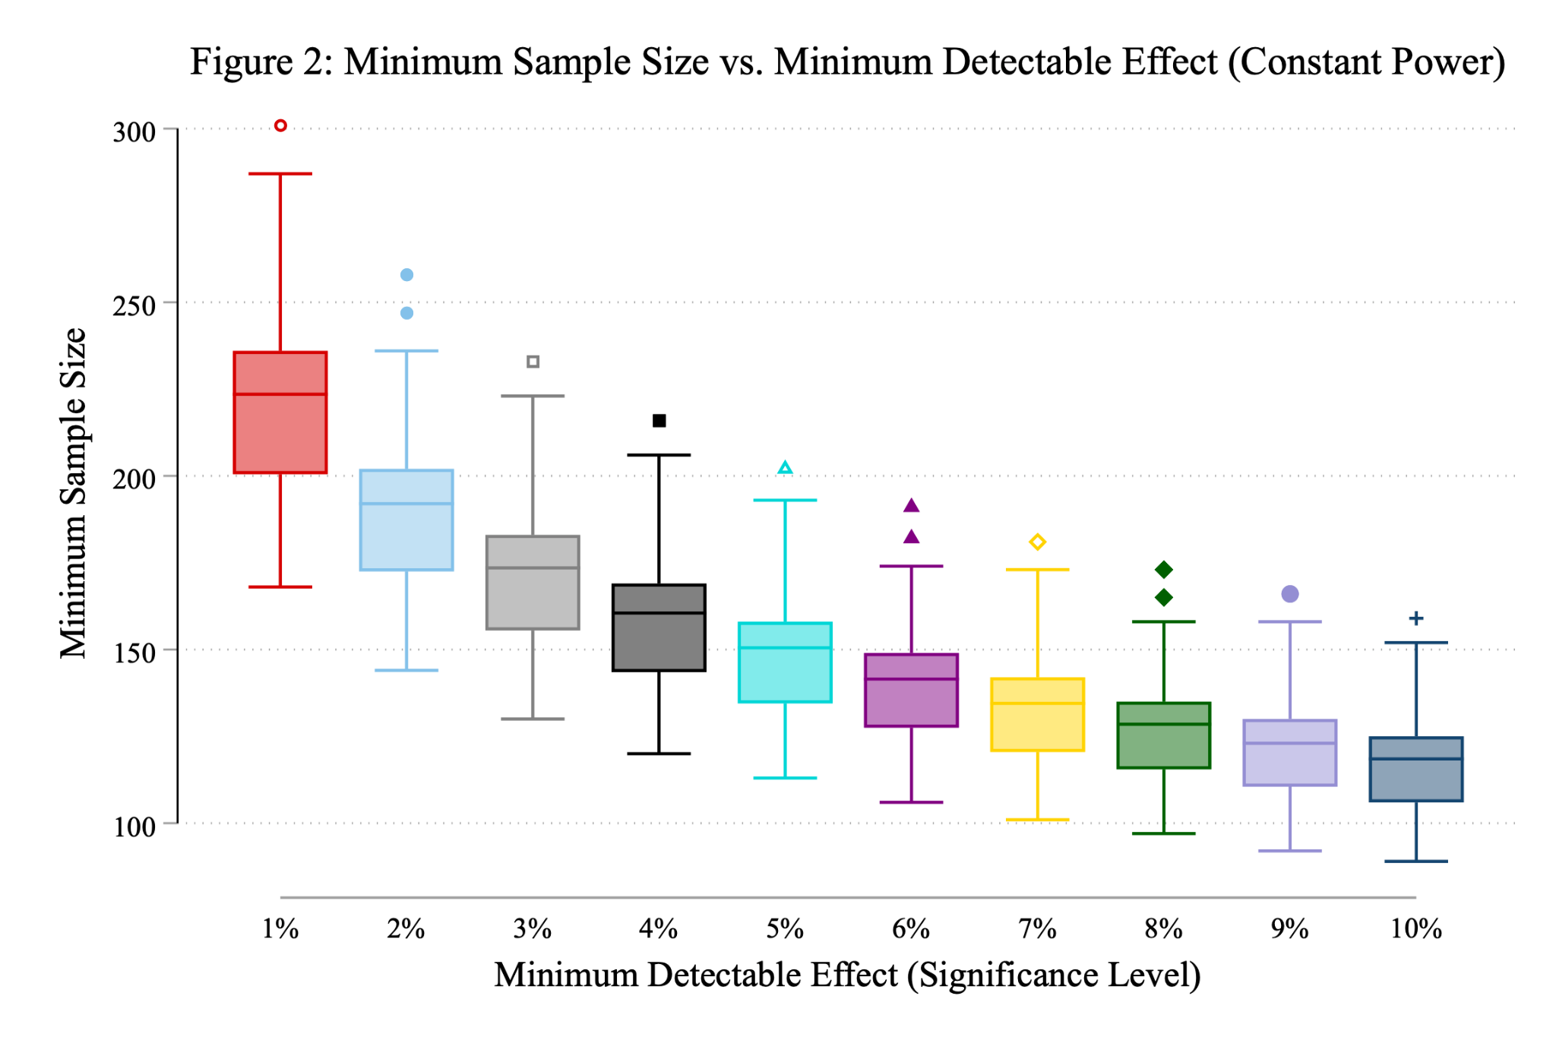

**3.6 Potential Threats to Identification**

We have concerns about school switching after the PK3 admissions cycle. We expect some students to switch to, from, and between charter schools, public schools, and private/parochial schools. If this number is large, however, it may threaten the statistical power of our study. Moreover, school switchers may have systematic characteristics that erode treatment randomness over time, which could bias our results. Summary statistics on such phenomena are not publicly available, so we cannot assess the size of the potential identification threat at this time. Nevertheless, in Table 3, we provide a framework detailing how our study would classify such situations.

**Table 3: Proposed Methodology for Encoding School Switchers**

|  |  |  |  |
| --- | --- | --- | --- |
| **From / To:** | **Charter** | **Public** | **Private** |
| **Charter** | No change | Code as untreated | Code as blank |
| **Public** | Code as treated | No change | Code as blank |
| **Private** | Out of sample | Out of sample | Out of sample |

Another potential threat to identification is heterogeneity in treatment compliance. While the system-wide takeup rate is 80% (Monarrez et al. 2020), we expect there to be significant heterogeneity across schools. If true, we would expect that some subsample of lower-quality charters would have a low takeup rate, meaning admission would be a weak instrument for those schools. This possibility may threaten the validity and applicability of our findings. Econometric adjustments for instrument-strength heterogeneity and significant subsample analysis may mitigate against this threat.

Lastly, we have concerns about the external validity of our study. Our research can be applied to other mid- or large-size US cities which also have limited PK3 school supplies but have experienced an increase in school-age children. However, since DC has unique legislation and policies that favor high oversight standards and lubricate charter entry, the model might not be very effective when applied to cities with different charter laws or oversight standards (Ferreyra and Kosenok 2018). While we conclude that both school administration and government oversight are critical to the high performance and quality of charter schools, cities that have little regulation or government intervention over charter schools might observe a different result. For example, regulators in DC. regularly oversee and evaluate the performance of each charter school to ensure class quality. Since the adaptation of the charter system in the 1990s, around 40% of the charters have been closed due to poor performance and strict government oversight (Ferreyra and Kosenok 2018). As a result, the model might be less applicable to cities that do not have a similar level of government scrutiny.

**Works Cited**

Abdulkadiroğlu, A., Josh D. Angrist, Susan M. Dynarski, Thomas J. Kane, and Parag A. Pathak. 2011. “Accountability and Flexibility in Public Schools: Evidence from Boston’s Charters and Pilots.” *Quarterly Journal of Economics* 126 (2): 699–748.<https://doi.org/10.1093/qje/qjr017>.

Abdulkadiroğlu, Atila, Joshua D. Angrist, Yusuke Narita, and Parag A. Pathak. 2017. “Research Design Meets Market Design: Using Centralized Assignment for Impact Evaluation.” *Econometrica* 85 (5): 1373–1432.<https://doi.org/10.3982/ECTA13925>.

Angrist, Joshua D., . Dynarski, Thomas J. Kane, Parag A. Pathak, and Christopher R. Walters. 2010. “Inputs and Impacts in Charter Schools: KIPP Lynn.” *American Economic Review* 100 (2): 239–43.<https://doi.org/10.1257/aer.100.2.239>.

Angrist, Joshua D., Guido W. Imbens, and Donald B. Rubin. 1996. “Identification of Causal Effects Using Instrumental Variables.” *Journal of the American Statistical Association* 91 (434): 444–55.<https://doi.org/10.1080/01621459.1996.10476902>.

Berk, Ronald A. 2005. “Survey of 12 Strategies to Measure Teaching Effectiveness.” *International Journal of Teaching and Learning in Higher Education* 17 (1): 48–62.<https://www.isetl.org/ijtlhe/pdf/IJTLHE8.pdf>.

Betts, Julian R., and Y. Emily Tang. 2014. “A Meta-Analysis of the Literature on the Effect of Charter Schools on Student Achievement.” Tempe, AZ: Center for Reinventing Public Education (CRPE), Mary Lou Fulton Teachers College, Arizona State University.<https://crpe.org/a-meta-analysis-of-the-literature-on-the-effect-of-charter-schools-on-student-achievement/>.

Blagg, Kristin, Victoria Rosenboom, and Matthew Chingos. 2018. “The Extra Mile: Time to School and Student Outcomes in Washington, DC.” Washington, DC: Urban Institute.<https://www.urban.org/research/publication/extra-mile-time-school-and-student-outcomes-washington-dc>.

Buckley, Jack, and Mark Schneider. 2006. “Are Charter School Parents More Satisfied with Schools? Evidence from Washington, DC.” *Peabody Journal of Education*, Contemporary School Choice Research, 81 (1): 57–78.<https://doi.org/10.1207/S15327930pje8101_4>.

Center on the Developing Child. 2007. “A Science-Based Framework for Early Childhood Policy.” Cambridge, MA: Harvard University.<https://developingchild.harvard.edu/resources/a-science-based-framework-for-early-childhood-policy/>.

Cheng, Albert, Collin Hitt, Brian Kisida, and Jonathan N. Mills. 2017. “‘No Excuses’ Charter Schools: A Meta-Analysis of the Experimental Evidence on Student Achievement.” *Journal of School Choice* 11 (2): 209–38.<https://doi.org/10.1080/15582159.2017.1286210>.

Clotfelter, Charles T., Helen F. Ladd, and Jacob L. Vigdor. 2009. “Are Teacher Absences Worth Worrying about in the United States?” *Education Finance and Policy* 4 (2): 115–49.

Cohodes, Sarah, and Katharine Parham. 2021. “Charter Schools’ Effectiveness, Mechanisms, and Competitive Influence.” w28477. Cambridge, MA: National Bureau of Economic Research.<https://doi.org/10.3386/w28477>.

Common Lottery Board. 2022. “Data.” My School DC. 2022.<https://www.myschooldc.org/resources/data>.

Curto, Vilsa E., and Roland G. Fryer. 2014. “The Potential of Urban Boarding Schools for the Poor: Evidence from SEED.” *Journal of Labor Economics* 32 (1): 65–93.<https://doi.org/10.1086/671798>.

DC Public Charter School Board. 2021. “Eleven Schools to Offer Equitable Access Admissions Preference.” September 16, 2021.<https://dcpcsb.org/eleven-schools-offer-equitable-access-admissions-preference>.

Dobbie, Will, and Roland G. Fryer. 2011. “Are High-Quality Schools Enough to Increase Achievement among the Poor? Evidence from the Harlem Children’s Zone.” *American Economic Journal: Applied Economics* 3 (3): 158–87.<https://doi.org/10.1257/app.3.3.158>.

Dougherty, Michael J. 2009. “Closing the Gap: Inverting the Genetics Curriculum to Ensure an Informed Public.” *American Journal of Human Genetics* 85 (1): 6–12.<https://doi.org/10.1016/j.ajhg.2009.05.010>.

Ferreyra, Maria Marta, and Grigory Kosenok. 2018. “Charter School Entry and School Choice: The Case of Washington, DC.” *Journal of Public Economics* 159 (March): 160–82.<https://doi.org/10.1016/j.jpubeco.2017.12.008>.

Finn, Chester E., Jr., Bruno V. Manno, and Gregg Vanourek. 2001. *Charter Schools in Action: Renewing Public Education*. Princeton, NJ: Princeton University Press.

Gleason, Philip, Melissa Clark, Christina Clark Tuttle, Emily Dwoyer, and Marsha Silverberg. 2010. “The Evaluation of Charter School Impacts: Final Report.” NCEE 2010-4029. Washington, DC: US Department of Education.<https://ies.ed.gov/ncee/pubs/20104029/pdf/20104029.pdf>.

Greenberg, Erica, Grace Luetmer, Carina Chien, and Tomás Monarrez. 2020. “Who Wins the Preschool Lottery?” Washington, DC: Urban Institute.<https://www.urban.org/research/publication/who-wins-preschool-lottery-applicants-and-application-patterns-dc-public-prekindergarten>.

Griffith, David. 2017. “Teacher Absenteeism in Charter and Traditional Public Schools.” Washington, DC: Thomas B. Fordham Institute.<https://edexcellence.net/publications/teacher-absenteeism>.

Herrmann, Mariesa A., and Jonah E. Rockoff. 2012. “Worker Absence and Productivity: Evidence from Teaching.” *Journal of Labor Economics* 30 (4): 749–82.<https://doi.org/10.1086/666537>.

Hill, Paul, Robin Lake, Mary Beth Celio, Christine Campbell, Paul Herdman, and Katrina Bulkley. 2001. “A Study of Charter School Accountability.” SAI-2001-3000. Washington, DC: Office of Educational Research and Improvement, US Department of Education.<https://eric.ed.gov/?id=ED455563>.

Hirschman, Albert O. 1970. *Exit, Voice, and Loyalty: Responses to Decline in Firms, Organizations, and States*. Cambridge, MA: Harvard University Press.

Hoxby, Caroline, and Sonali Murarka. 2009. “Charter Schools in New York City: Who Enrolls and How They Affect Their Students’ Achievement.” w14852. Cambridge, MA: National Bureau of Economic Research.<https://doi.org/10.3386/w14852>.

Jacobs, Nicholas. 2013. “Understanding School Choice: Location as a Determinant of Charter School Racial, Economic, and Linguistic Segregation.” *Education and Urban Society* 45 (4): 459–82.<https://doi.org/10.1177/0013124511413388>.

Lacireno-Paquet, Natalie, Thomas T. Holyoke, Michele Moser, and Jeffrey R. Henig. 2002. “Creaming versus Cropping: Charter School Enrollment Practices in Response to Market Incentives.” *Educational Evaluation and Policy Analysis* 24 (2): 145–58.<https://doi.org/10.3102/01623737024002145>.

Lumpkin, Lauren. 2022. “DC School Enrollment Hits 15-Year High, Mayor Says.” *Washington Post*, November 14, 2022.<https://www.washingtonpost.com/education/2022/11/14/dc-schools-public-charter-enrollment/>.

Miller, Raegen T., Richard J. Murnane, and John B. Willett. 2008. “Do Teacher Absences Impact Student Achievement? Longitudinal Evidence from One Urban School District.” *Educational Evaluation and Policy Analysis* 30 (2): 181–200.<https://doi.org/10.3102/0162373708318019>.

Min, Sookweon, and Peter T. Goff. 2016. “The Relations of a School’s Capacity for Institutional Diversity to Student Achievement in Socio-Economically, Ethnically, and Linguistically Diverse Schools.” *International Journal of Inclusive Education* 20 (12): 1310–25.<https://doi.org/10.1080/13603116.2016.1168876>.

Mintrom, Michael. 2000. “Leveraging Local Innovation: The Case of Michigan’s Charter Schools.” East Lansing, MI: Michigan State University.<https://education.msu.edu/epc/forms/innovation.pdf>.

Monarrez, Tomás, Erica Greenberg, Grace Luetmer, and Carina Chien. 2020. “Using Centralized Lotteries to Measure Preschool Impact.” Washington, DC: Urban Institute.<https://www.urban.org/research/publication/using-centralized-lotteries-measure-preschool-impact>.

Nathan, Joe. 1996. *Charter Schools: Creating Hope and Opportunity for American Education*. Jossey-Bass Education Series. San Francisco, CA: Jossey-Bass Publishers.<https://eric.ed.gov/?id=ED410657>.

Office of the State Superintendent of Education. 2019. “DC Statewide Assessment Results.” Washington, DC.<https://osse.dc.gov/page/2018-19-parcc-results-and-resources>.

Posner, Richard A. 1986. “Goodbye to the Bluebook.” *University of Chicago Law Review* 53 (4): 1343–68.<https://doi.org/10.2307/1599750>.

Powell, Judith, Jose Blackorby, Julie Marsh, Kara Finnegan, and Lee Anderson. 1997. “Evaluation of Charter School Effectiveness: Part I.” Sacramento, CA: SRI International.<https://lao.ca.gov/1997/121197_charter_schools/sri_charter_schools_1297-part1.html>.

Rosenblum Brigham Associates. 1998. “Innovation and Massachusetts Charter Schools.” Boston, MA: Massachusetts Department of Education.

Schneider, Mark, and Jack Buckley. 2003. “Making the Grade: Comparing DC Charter Schools to Other DC Public Schools.” *Educational Evaluation and Policy Analysis* 25 (2): 203–15.<https://doi.org/10.3102/01623737025002203>.

Setren, Elizabeth. 2019. “Targeted vs. General Education Investments: Evidence from Special Education and English Language Learners in Boston Charter Schools.” *Journal of Human Resources* 56 (4): 1073–1112.<https://doi.org/10.3368/jhr.56.4.0219-10040R2>.

Walters, Christopher R. 2018. “The Demand for Effective Charter Schools.” *Journal of Political Economy* 126 (6): 2179–2223.<https://doi.org/10.1086/699980>.

Wohlstetter, Priscilla, and Noelle C. Griffin. 1997. “Creating and Sustaining Learning Communities: Early Lessons from Charter Schools.” Philadelphia, PA: Consortium for Policy Research in Education.<https://eric.ed.gov/?id=ED410642>.

Wohlstetter, Priscilla, Richard Wenning, and Kerri L. Briggs. 1995. “Charter Schools in the United States: The Question of Autonomy.” *Educational Policy* 9 (4): 331–58.<https://doi.org/10.1177/0895904895009004001>.

Wolderie, Ted. 1990. “Beyond Choice to New Public Schools: Withdrawing the Exclusive Franchise in Public Education.” Policy Report No. 8. Washington, DC: Progressive Policy Institute.<https://eric.ed.gov/?id=ED327914>.

Yoshikawa, Hirozaku, Christina Weiland, Jeanne Brooks-Gunn, Margaret R. Burchinal, Linda M. Espinosa, William T. Gormley, Jens Ludwig, Katherine A. Magnuson, Deborah Phillips, and Martha J. Zaslow. 2013. *Investing in Our Future: The Evidence Base on Preschool Education*. New York, NY: Society for Research in Child Development.<https://www.fcd-us.org/the-evidence-base-on-preschool/>.

Zimmer, Ron, Brian Gill, Kevin Booker, Stephane Lavertu, Tim Sass, and John Witte. 2009. *Charter Schools in Eight States: Effects on Achievement, Attainment, Integration, and Competition*. Santa Monica, CA: RAND Corporation.<https://doi.org/10.7249/MG869>.

1. We borrow this terminology from economist Albert O. Hirschman, the author of *Exit, Voice, and Loyalty: Responses to Decline in Firms, Organizations, and States* (1970).
2. Instructor absenteeism is, admittedly, an imperfect measure of instructor quality. We may also consider levels of education, student performance on standardized tests, student feedback surveys, and job tenure as other (imperfect) proxies of instructor quality. Using multiple measures concurrently will enhance the reliability of findings.
3. Note that, while the charter selection system is called the My School DC *Lottery*, not all students are actually entered into random lottery. Rather, only applicants to charters where demand outstrips supply are subjected to random lottery. This misnomer can cause confusion; to that end, we avoid calling the selection process a *lottery*.
4. This must be distinguished from the intent-to-treat (ITT) effect, which estimates the impact of winning a charter lottery relative to losing one.
5. A classic example of a measure that might be biased is student suspensions. Some schools, as a matter of policy, have a higher/lower threshold for suspensions. Thus, differences in suspension rates may simply be the result of differences in school policy rather than student behavior.
6. We use the initialism MSN, rather than MSS, to avoid confusion with the mean sum of squares.